**Lab-6**

**Question #1:**

Simplify the Product-Of-Sums Boolean (PoS) expression below.



Out=πM(1,2,5,6,9,10,14)

Out=Σm(1,2,5,6,9,10,14)

**K-MAP:**

|  |  |  |  |  |
| --- | --- | --- | --- | --- |
|  | **C’D’** | **C’D** | **CD** | **CD’** |
| **A’B’** |  | 0 |  | 0 |
| **A’B** |  | 0 |  | 0 |
| **AB** |  |  |  | 0 |
| **AB’** |  | 0 |  | 0 |

Out’=CD’+AC’D’+B’C’D’

Out=(C’+D)(A’+C+D)(B+C+D)

**NOR and NAND Implementation on logic trainer:**

**Question#2:**

Implement following expressions on **Logic Works** using **only** the **NAND gates.**

**(Use ICs to implement logics)**

1. **Z = A.B           (b)  X = A+B (c)  XNOR**

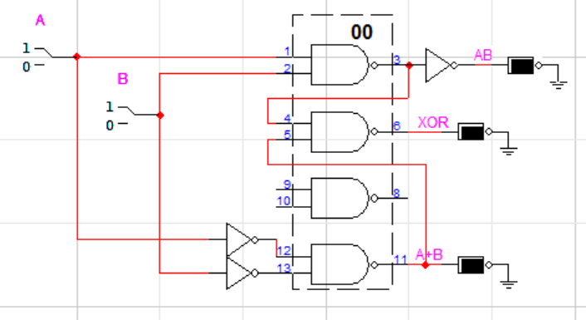

**Question#3:**

Implement following expressions on **Logic Works** using only the **NOR gates.**

**(Use ICs to implement logics)**

1. **Z = A.B             (b)  X = A+B (c)  XOR**

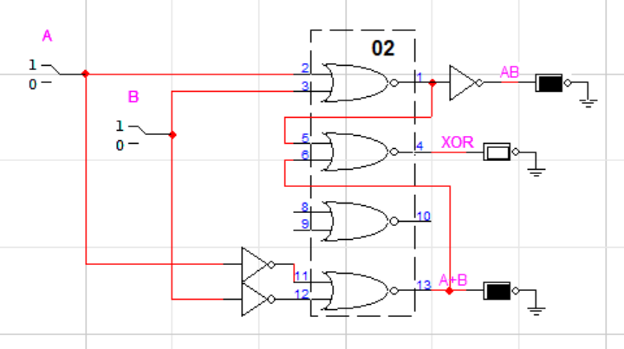

**Question # 4:**

For the Boolean function  F1(A,B,C,D)=m(2,4,12,14)  perform the following tasks:

1. Find truth table

|  |  |  |  |  |  |
| --- | --- | --- | --- | --- | --- |
| **A** | **B** | **C** | **D** |  | **F1** |
| 0 | 0 | 0 | 0 | A’B’C’D’ | 0 |
| 0 | 0 | 0 | 1 | A’B’C’D | 0 |
| 0 | 0 | 1 | 0 | A’B’CD’ | 1 |
| 0 | 0 | 1 | 1 | ABCD | 0 |
| 0 | 1 | 0 | 0 | A’BC’D | 1 |
| 0 | 1 | 0 | 1 | - | 0 |
| 0 | 1 | 1 | 0 | - | 0 |
| 0 | 1 | 1 | 1 | - | 0 |
| 1 | 0 | 0 | 0 | - | 0 |
| 1 | 0 | 0 | 1 | - | 0 |
| 1 | 0 | 1 | 0 | - | 0 |
| 1 | 0 | 1 | 1 | - | 0 |
| 1 | 1 | 0 | 0 | - | 1 |
| 1 | 1 | 0 | 1 | - | 0 |
| 1 | 1 | 1 | 0 | ABCD’ | 1 |
| 1 | 1 | 1 | 1 |  | 0 |

1. Find minimal SOP expression for Boolean function F1 using K-map. Draw K-map.

|  |  |  |  |  |
| --- | --- | --- | --- | --- |
|  | **C’D’** | **C’D** | **CD** | **CD’** |
| **A’B’** |  |  |  | 1 |
| **A’B** | 1 |  |  |  |
| **AB** | 1 |  |  | 1 |
| **AB’** |  |  |  |  |

F1=BC’D’+AC’D’+A’B’CD’

1. Draw the resultant expression obtained in part (b) and implement on **Logic Works** using **only NAND gates.**

